**Spring boot rest API testing result using Soup UI**

1. Fetch all coffee types from database

End Point (/coffeeTypes)

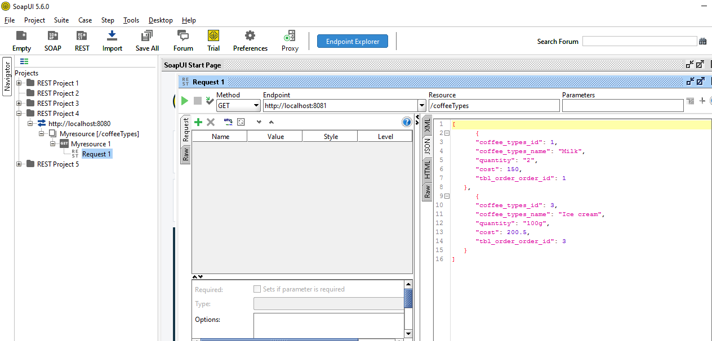

1. Fetch coffee types by ID

End Point (/coffeeTypes/2)

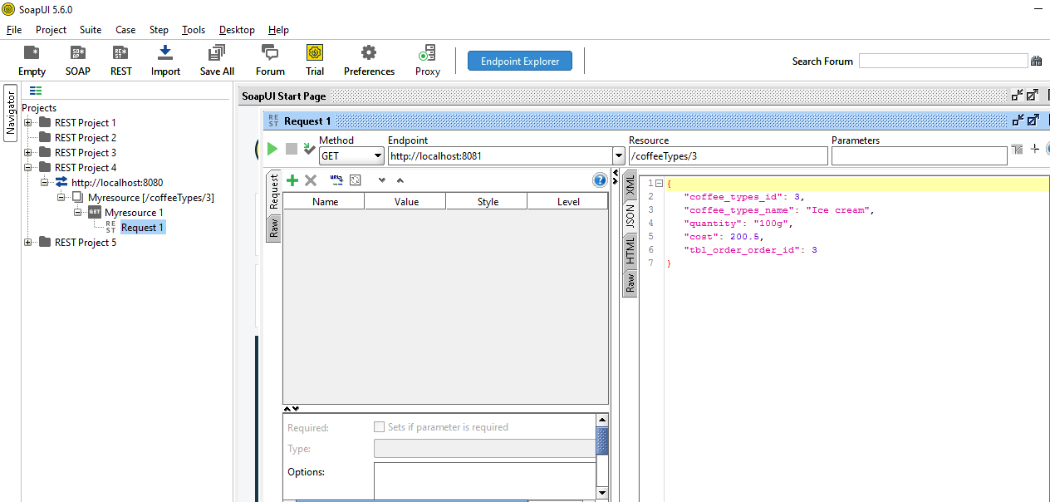

1. Inserting coffee types to the database

End Point (/coffeeTypes)

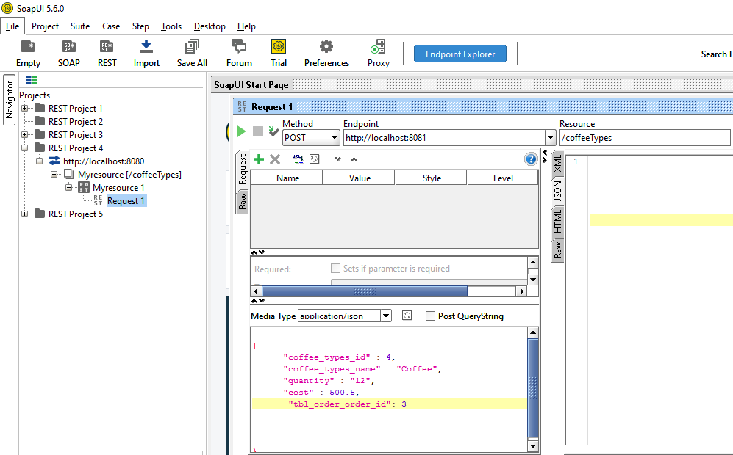

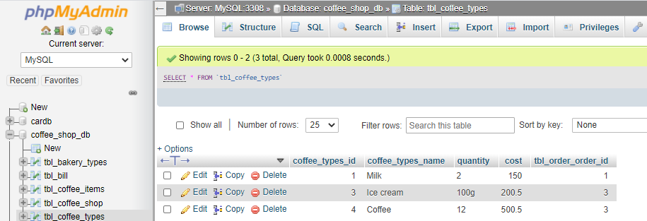

1. Updating coffee Types

End Point (/coffeeTypes)

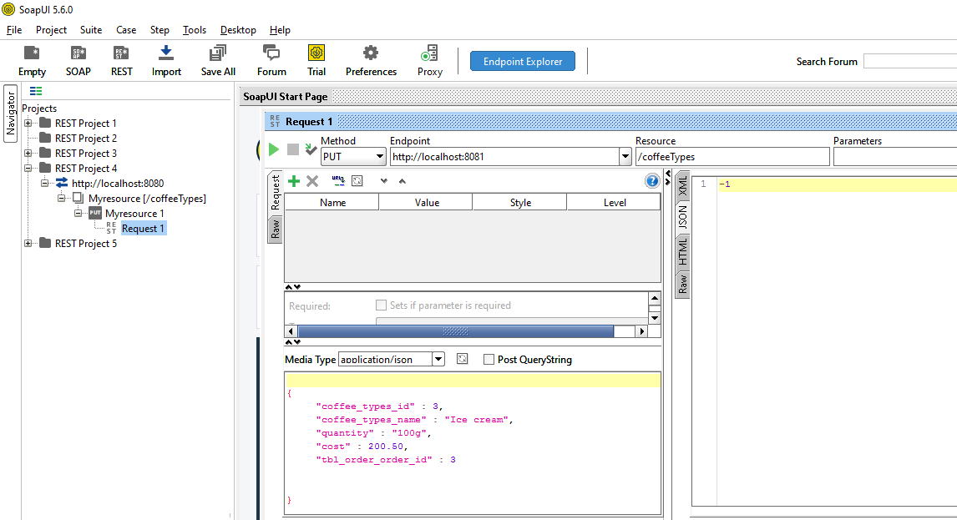

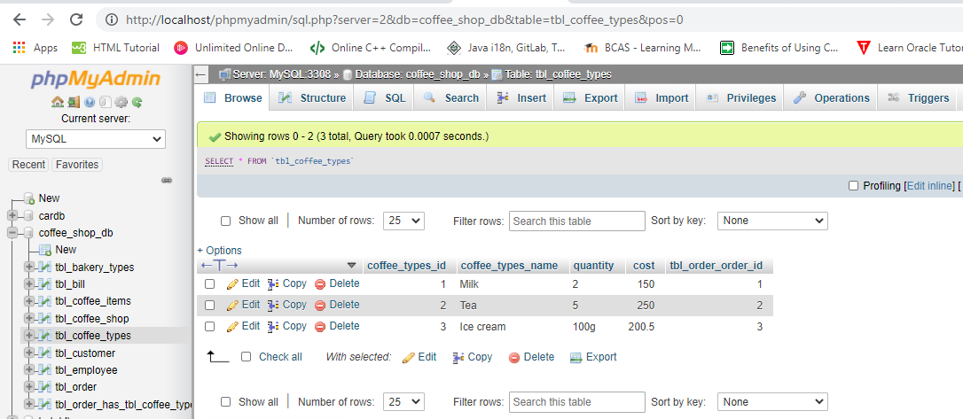

1. Deleting Coffee Types from database

End Point (/coffeeTypes/2)

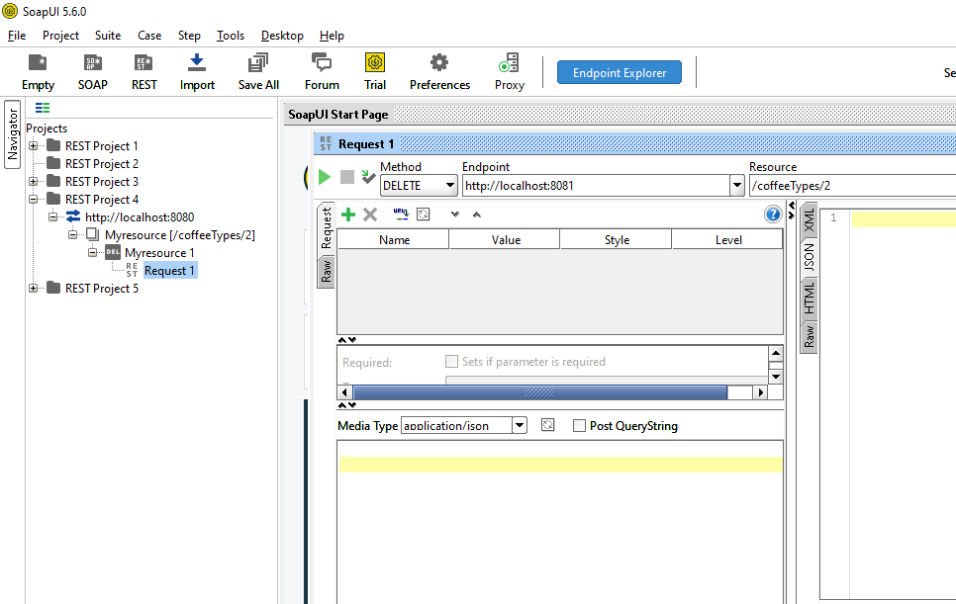

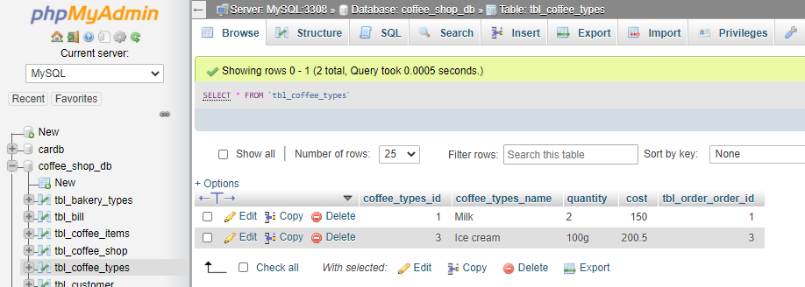

Get all coffee items

1. Fetch all coffee items from database

End Point (/coffeeitems)

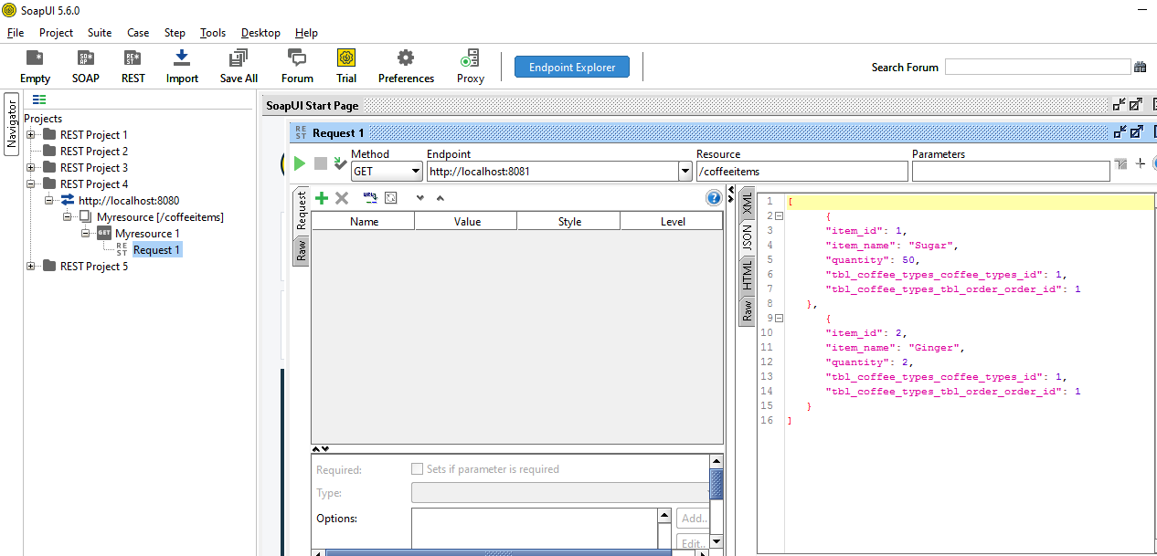

Get coffee items by id

1. Fetch coffee items by ID

End Point (/coffeeitems/1)

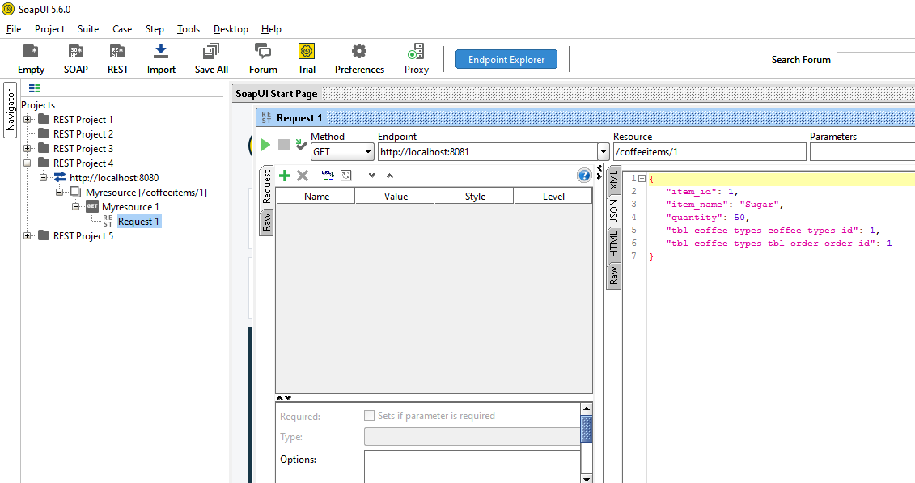

1. Inserting coffee items to the database

End Point (/coffeeitems)

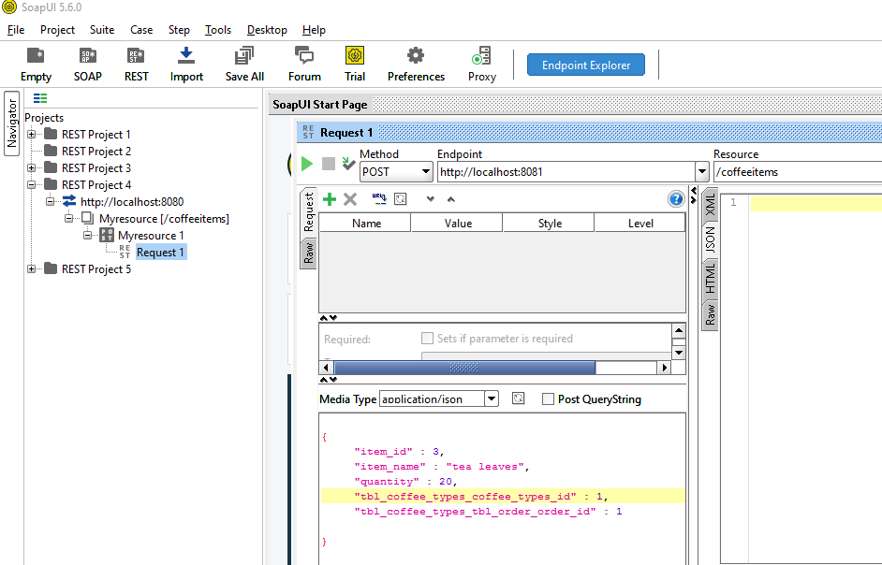

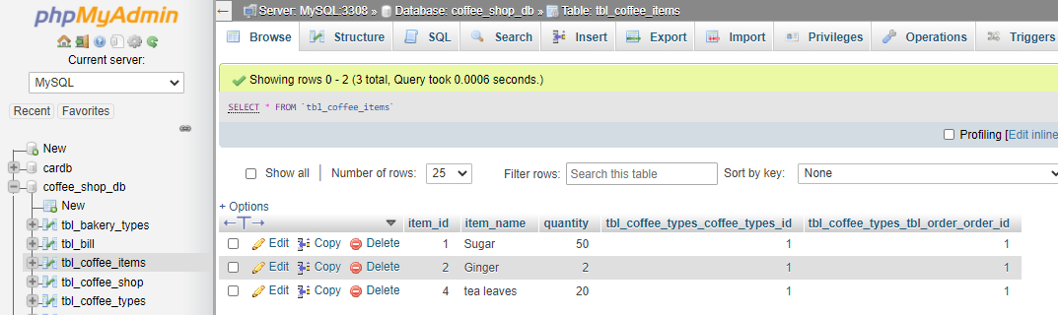

1. Updating coffee items

End Point (/coffeeitems)

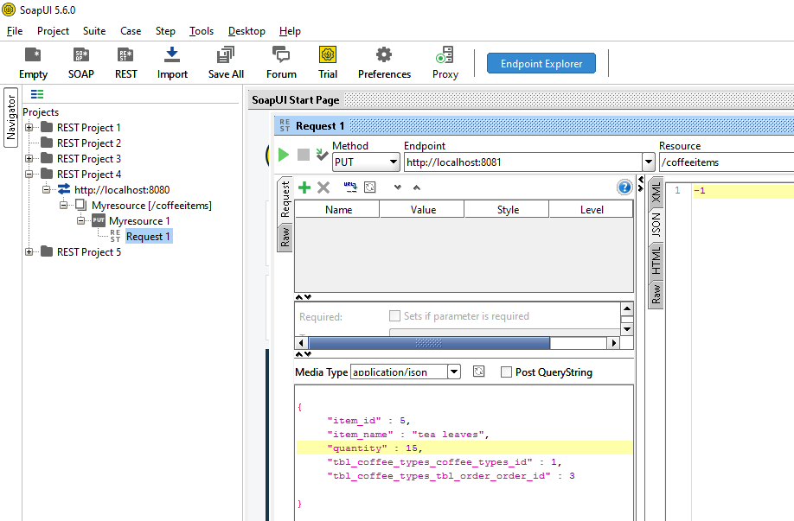

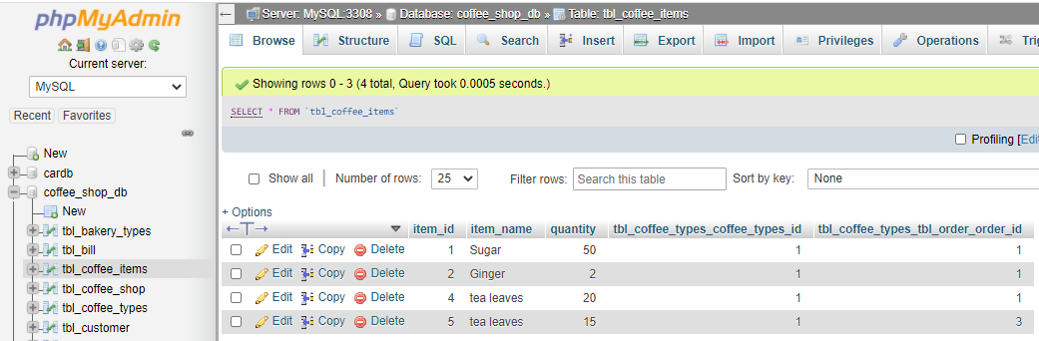

1. Deleting coffee items from database

End Point (/coffeeitems/4)

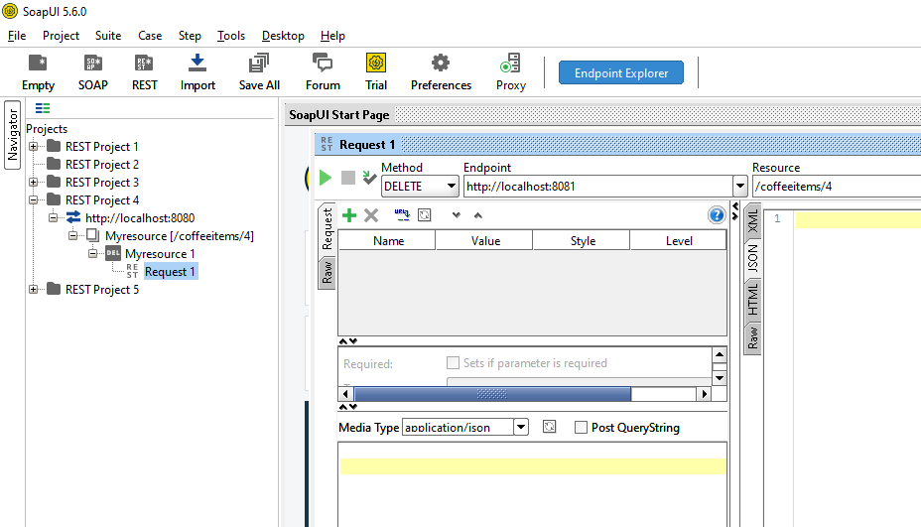

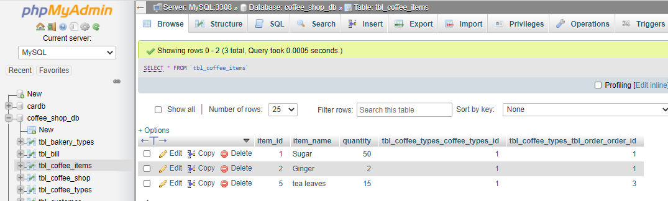

Get all bakery types

1. Fetch all bakery types from database

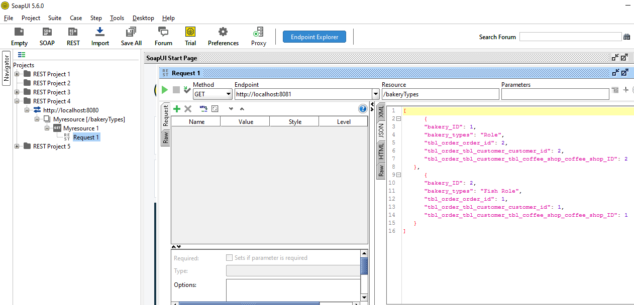End Point (/bakeryTypes)

1. Fetch bakery types by ID

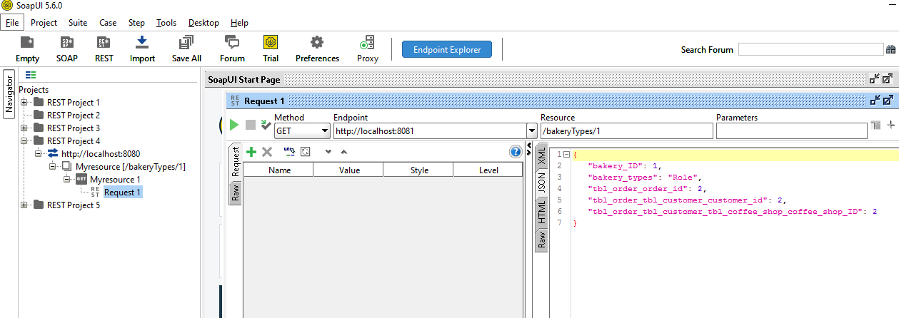End Point (/bakeryTypes/1)

1. Inserting bakery types to database

End Point (/bakeryTypes)

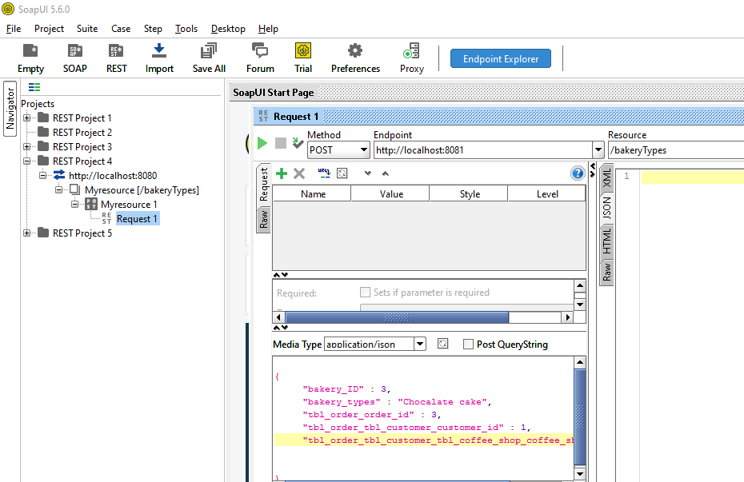

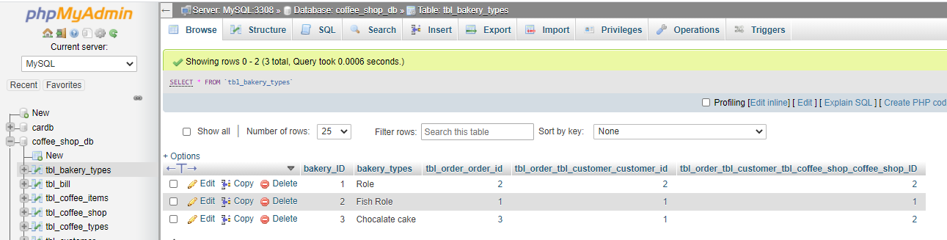

1. Updating bakery types

End Point (/bakeryTypes)

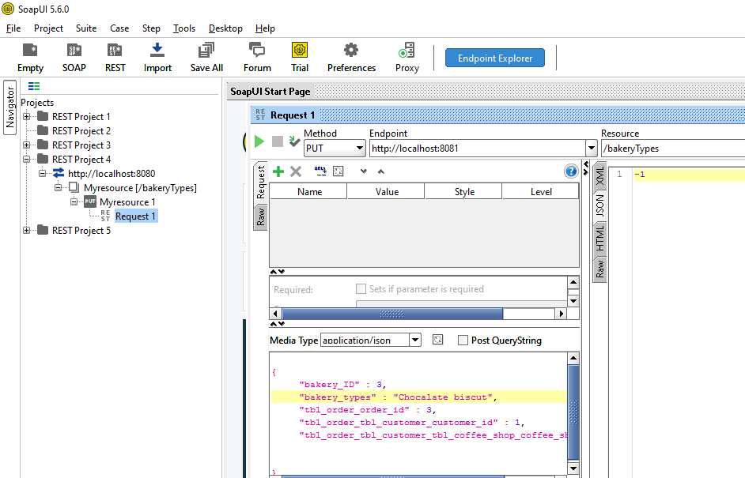

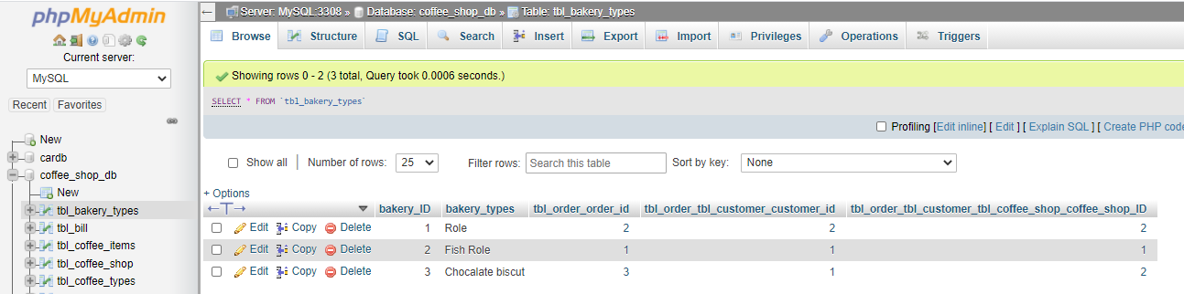

1. Deleting bakery types by Id

End Point (/bakeryTypes/2)

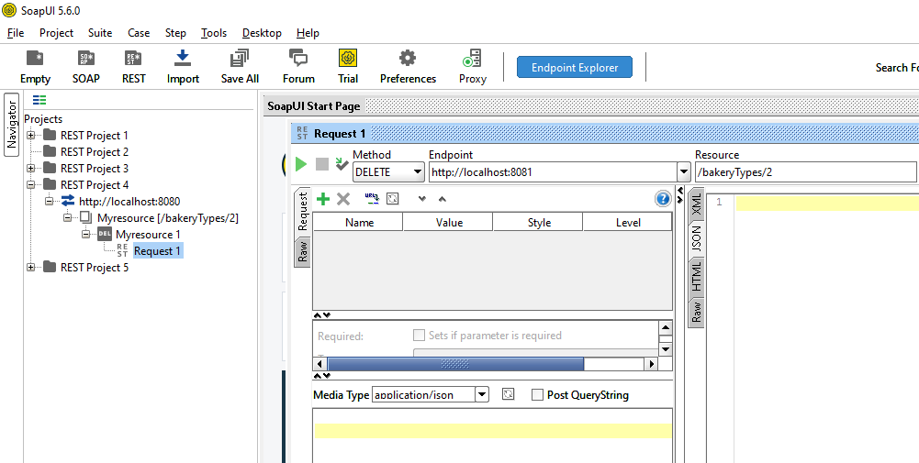

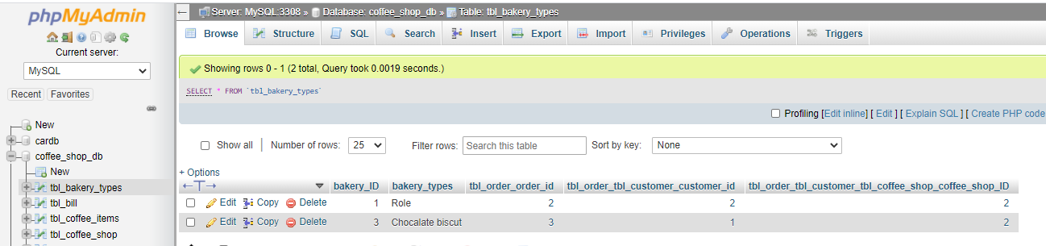

1. fetch all customers from database

End Point (/customer)

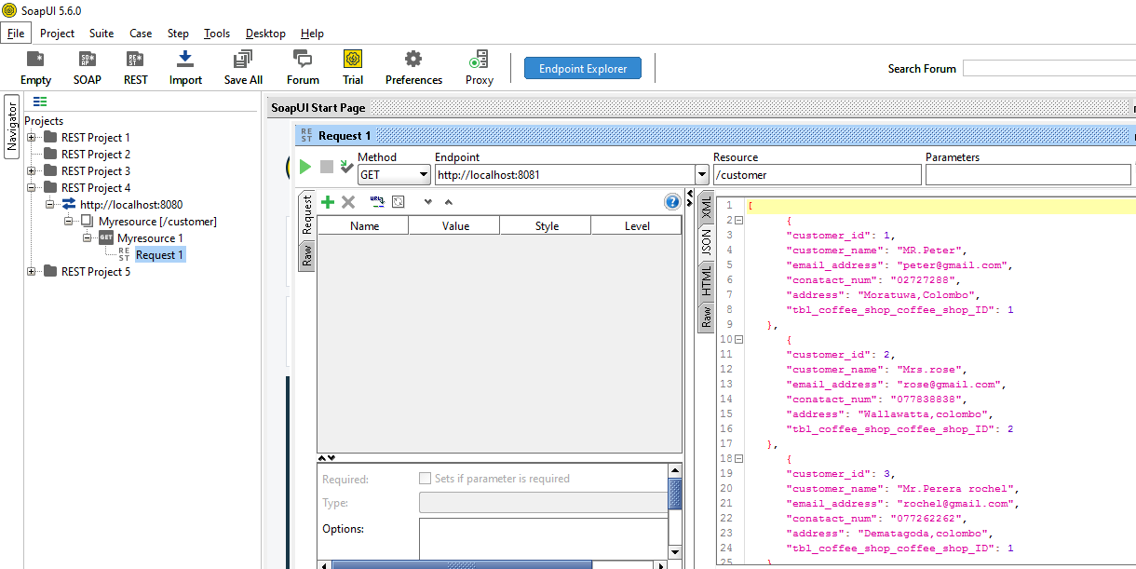

1. Fetch customers by id

End Point (/customer/1)

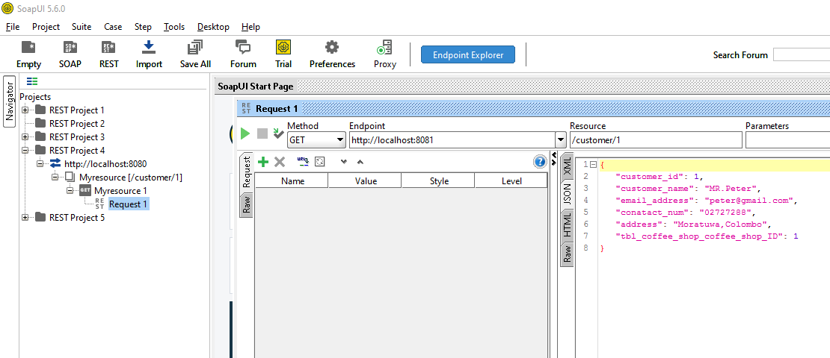

1. Inserting customer to the database

End Point (/customer)

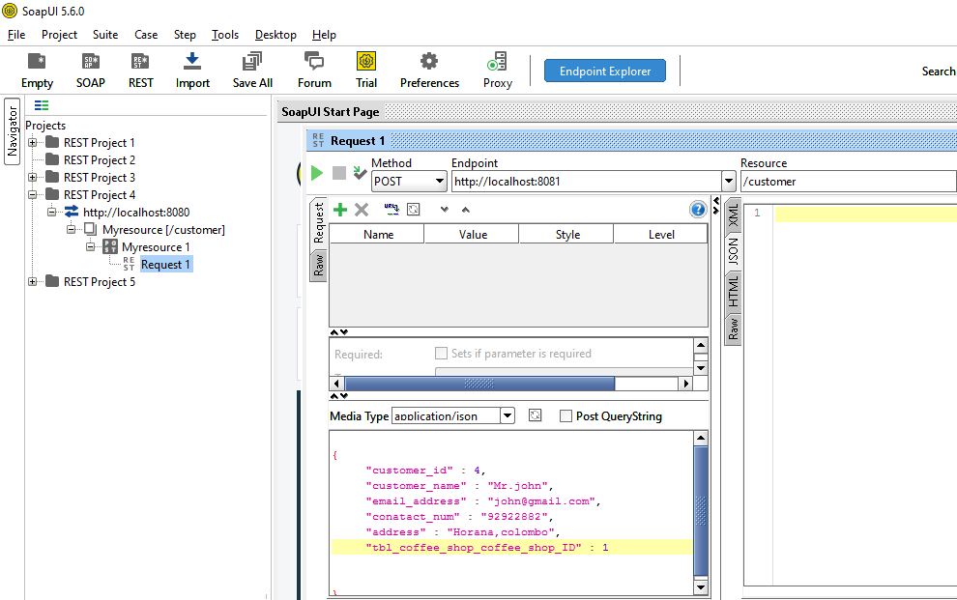

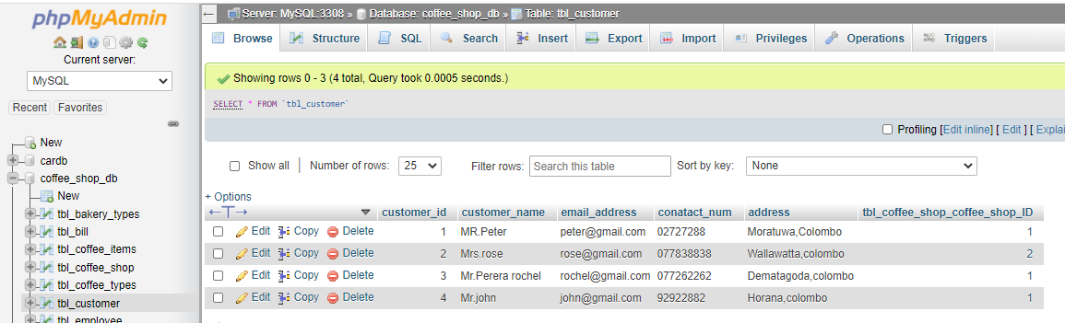

1. Updating customer

End Point (/customer)

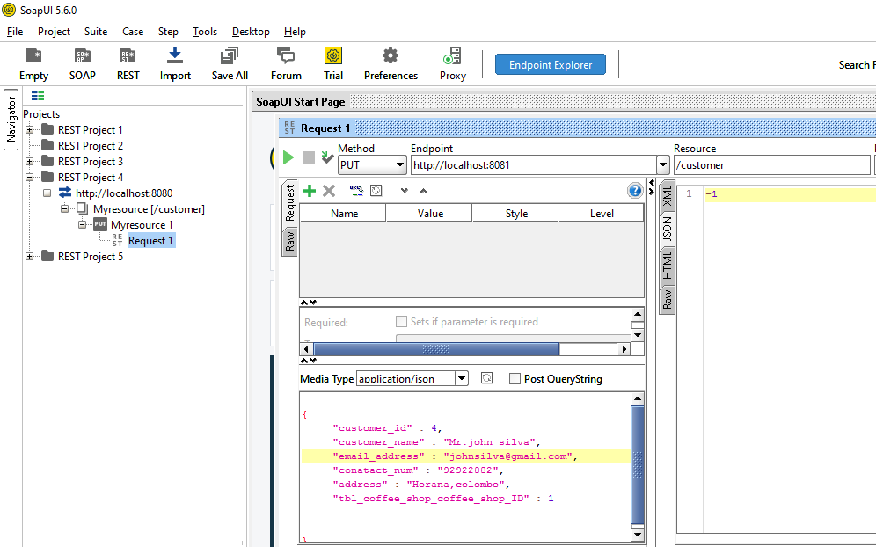

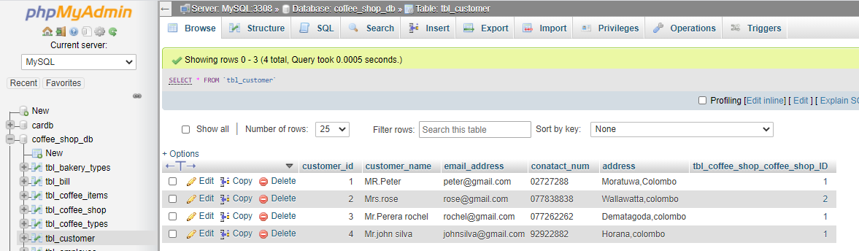

1. Deleting customer by ID

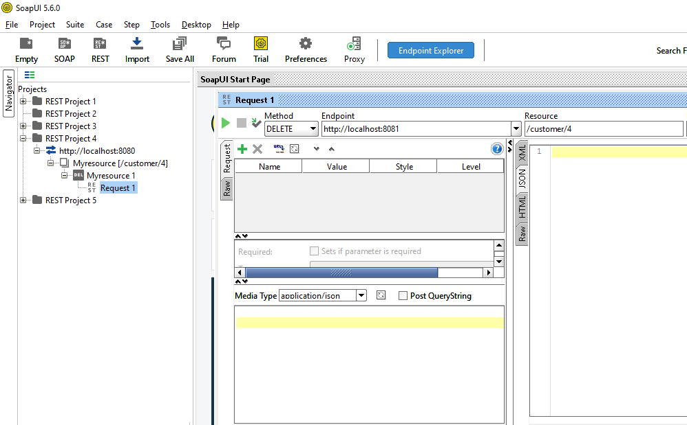End Point (/customer/4)

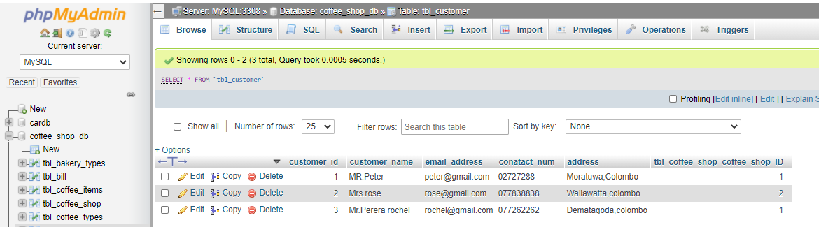

1. Fetch all employees from database

End point (/employee)

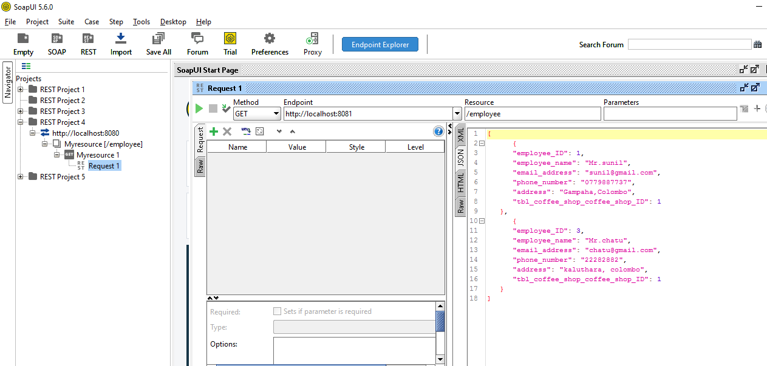

1. Fetch employees by ID

End Point (/employee/1)

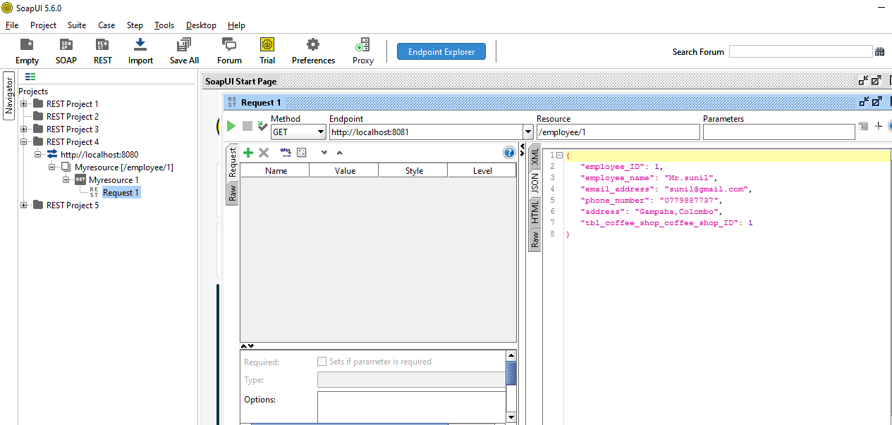

1. Inserting employee to the database

End Point (/employee)

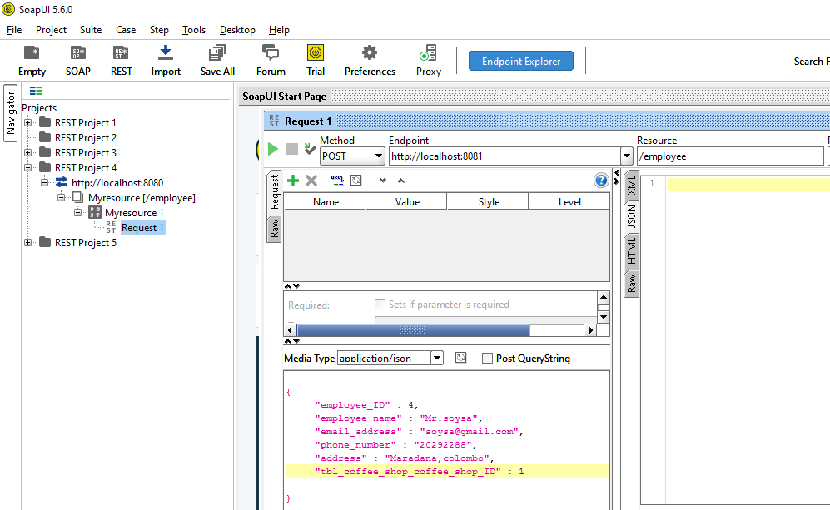

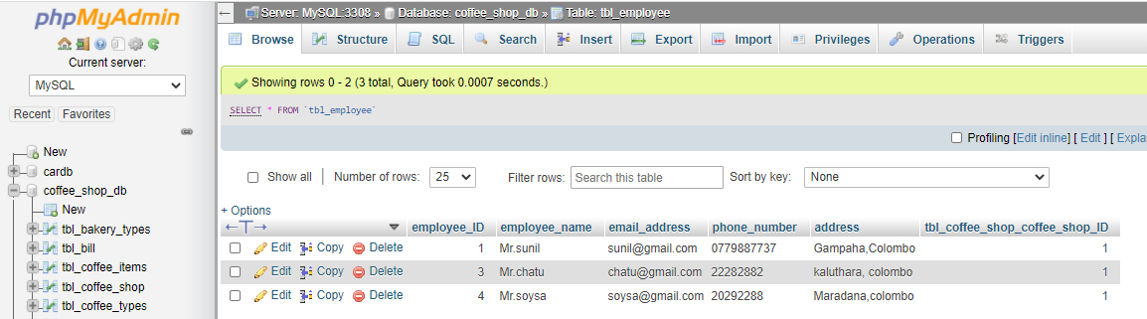

1. Updating employee

End Point (/employee)

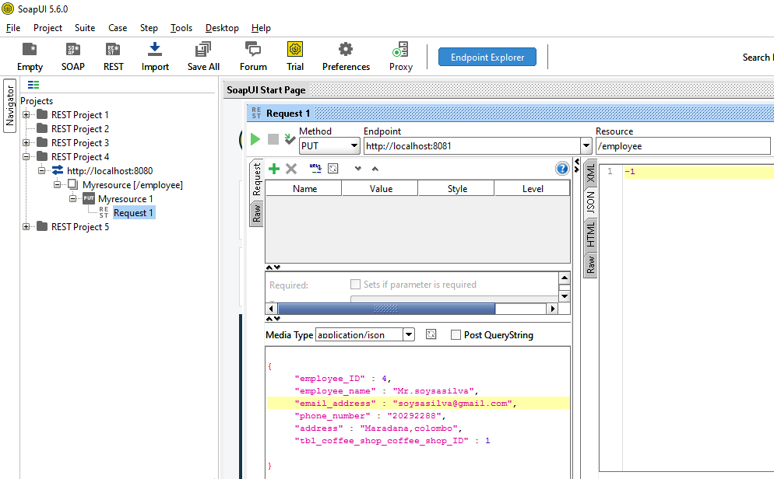

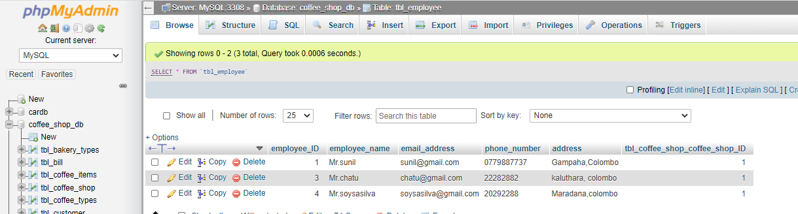

1. Deleting employee by ID

End Point (/employee/4)

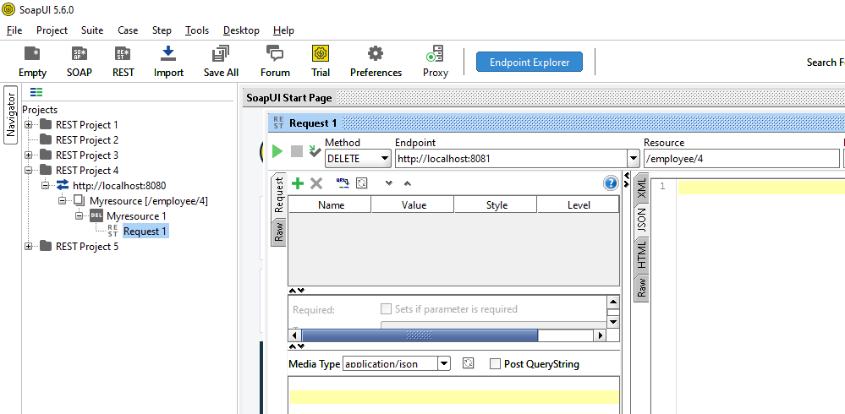

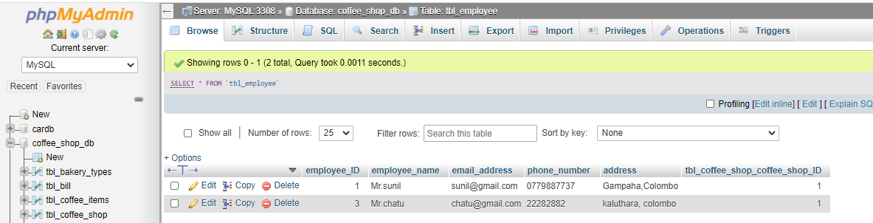

1. Fetch all order details from database

End Point (/order)

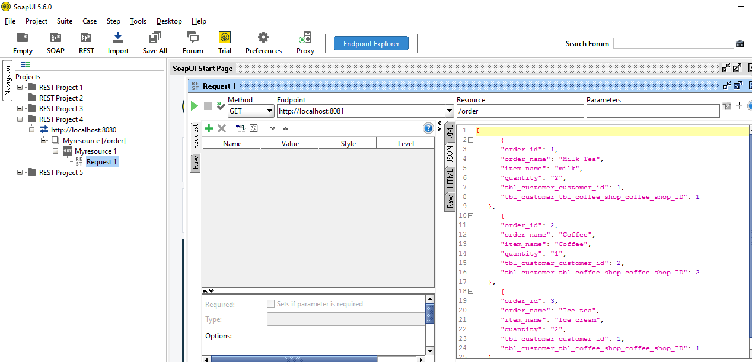

1. Fetch order details by ID

End Point (/order/3)

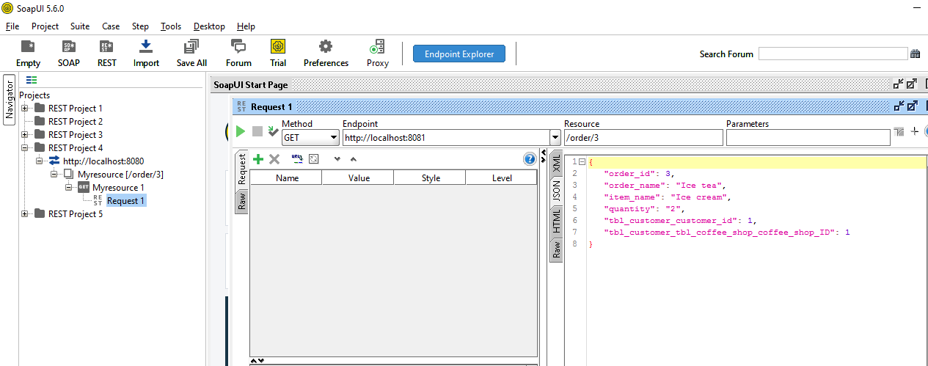

1. Inserting order details to the database

End Point (/order)

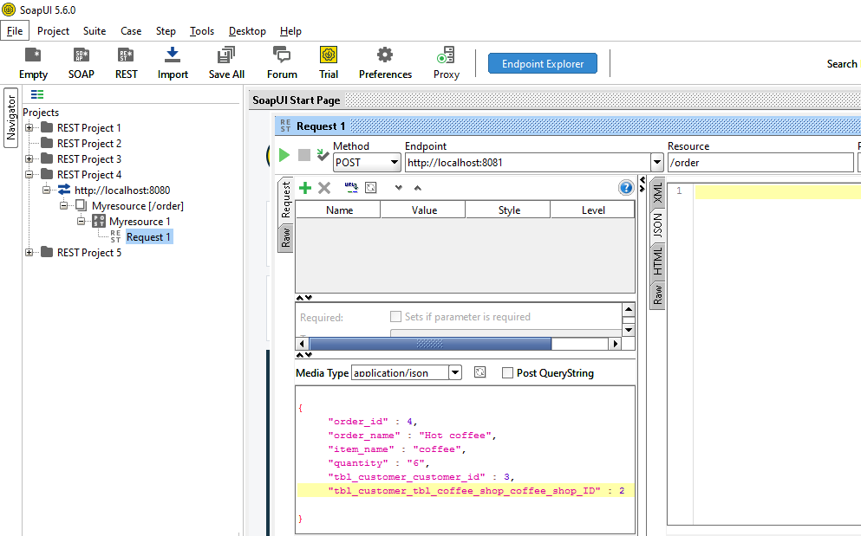

1. Updating order details

End Point (/order)

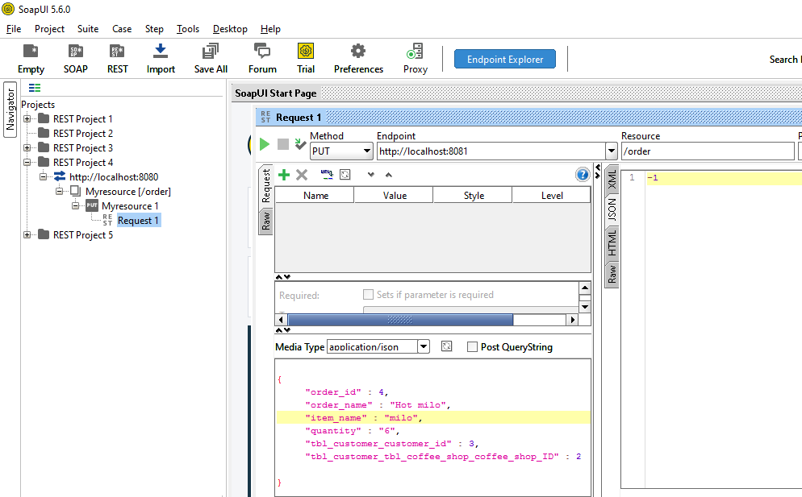

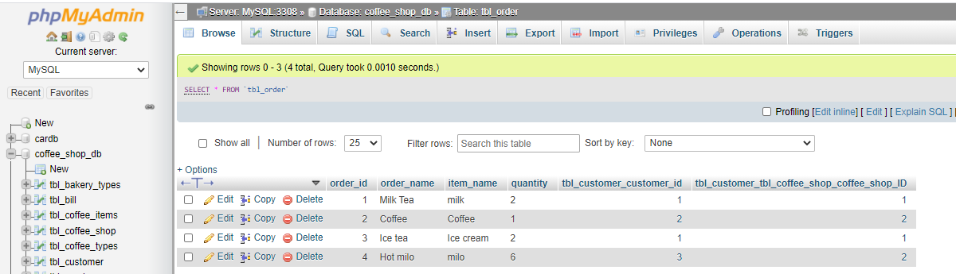

Swagger results

**Swagger UI results**

* Frontend developer can utilize the below rest API endpoints using swagger

